Name: Bodhisatya Ghosh
Class: CSE DS
Batch: B
UID: 2021700026
Experiment: 3

Aim: Implement the C program in which main program accepts the integers to be sorted. Main program uses the fork system call to create a new process called a child process. Parent process sorts the integers using merge sort and waits for child process using wait system call to sort the integers using quick sort. Also demonstrate zombie and orphan states

Program:

1. Using fork()

#include <stdio.h>
#include <unistd.h>
#include <stdlib.h>
#include <sys/types.h>
#include <sys/wait.h>

void merge(int arr[], int l, int m, int r)
{
int i, j, k;
int n1 = m - l + 1;
int n2 = r - m;
int L[n1], R[n2];
for (i = 0; i < n1; i++)
{
L[i] = arr[l + i];
}
for (j = 0; j < n2; j++)
{
R[j] = arr[m + 1 + j];
}
i = 0;
j = 0;
k = l;
while (i < n1 && j < n2)
{
if (L[i] <= R[j])
{
arr[k] = L[i];
i++;
}
else
{
arr[k] = R[j];
j++;
}
k++;
}
while (i < n1)
{
arr[k] = L[i];
i++;
k++;
}
while (j < n2)
{
arr[k] = R[j];
j++;
k++;
}
}

void mergeSort(int arr[],
int l, int r)
{
if (l < r)
{
int m = l + (r - l) / 2;
mergeSort(arr, l, m);
mergeSort(arr, m + 1, r);
merge(arr, l, m, r);
}
}

int partition (int a[], int start, int end)
{
int pivot = a[end];
int i = (start - 1);

for (int j = start; j <= end - 1; j++)
{
if (a[j] < pivot)
{
i++;
int t = a[i];
a[i] = a[j];
a[j] = t;
}
}
int t = a[i+1];
a[i+1] = a[end];
a[end] = t;
return (i + 1);
}

void quick(int a[], int start, int end)
{
if (start < end)
{
int p = partition(a, start, end);
quick(a, start, p - 1);
quick(a, p + 1, end);
}
}

void printArr(int A[], int size)
{
int i;
for (i = 0; i < size; i++)
{
printf("%d ", A[i]);
}
printf("\n");
}

void main()
{
int arr[10];
for(int i=0;i<10;i++)
{
printf("Enter element number %d: ",i+1);
scanf("%d",&arr[i]);
}
int n = sizeof(arr) / sizeof(arr[0]);
int parent=getpid();
printf("Entry of elements is in process ID: %d\n\n",parent);
int child=fork();
if(child<0)
{
printf("Child creation failure");
}
else if(child==0)
{
printf("This is the child process: %d\n",getpid());
//printf("Parent of this process is: %d\n",getppid());
printf("Original array: \n");
printArr(arr, n);
quick(arr, 0, n - 1);
printf("After quick sort: \n");
printArr(arr,n);
printf("Completed child process\n\n");
}
else
{
wait(NULL);
printf("This is the parent process: %d\n",getpid());
printf("Original array: \n");
printArr(arr, n);
mergeSort(arr, 0, n - 1);
printf("After merge sort: \n");
printArr(arr,n);
printf("Completed parent process\n\n");
}
}

2. To show orphan process

#include <stdio.h>
#include <unistd.h>
#include <sys/types.h>

void main()
{
int pid=fork();

if(pid>0)
{
printf("Parent process finished\n");
}
else if(pid==0)
{
sleep(10);
printf("The child process finished right now was an orphan\n");
}
else
{
printf("Process failed to create a child");
}
}

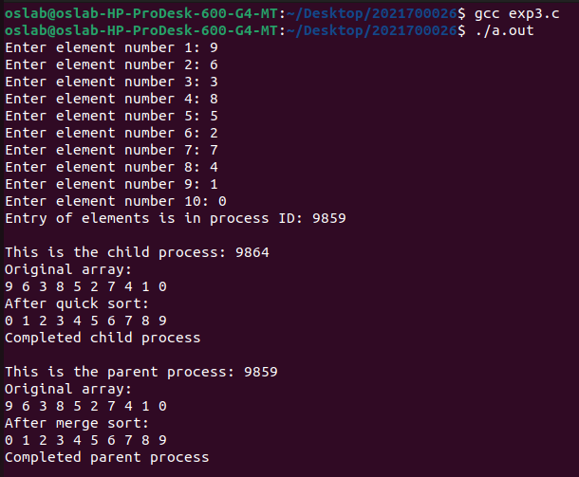
Output:

1. Using fork()

2. To show zombie process

